**Problem1**

$$A=\begin{matrix}0.99 & 0.01 \\ 0.03 & 0.97\end{matrix}$$

$$P_{2}^{T}=P_{1}^{T}*A=\left(\begin{matrix}0.75 & 0.25\end{matrix}\right)*\left(\begin{matrix}0.99 & 0.01 \\ 0.03 & 0.97\end{matrix}\right)=\left(\begin{matrix}0.75 & 0.25\end{matrix}\right)=P_{1}^{T}$$

$easily to know$, $P_{n}^{T}=P_{n-1}^{T}*A=…=P_{1}^{T}$

$$as a consequence, P\left(S_{j}=i\right) is constant for all t$$

**problem2**

below picture is the result from MATLAB, the relative frequency of occurrences of St = 1 and St = 2 are 0.7399 and 0.2601 respectively, which approximately equals to P(St);

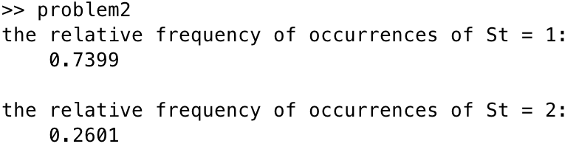

**problem 3**

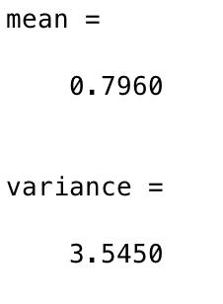

**problem 4**

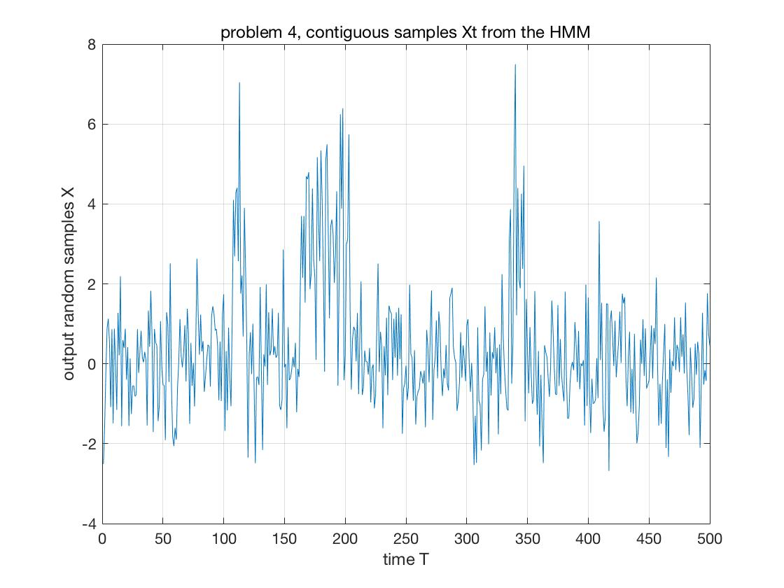

**problem 5**

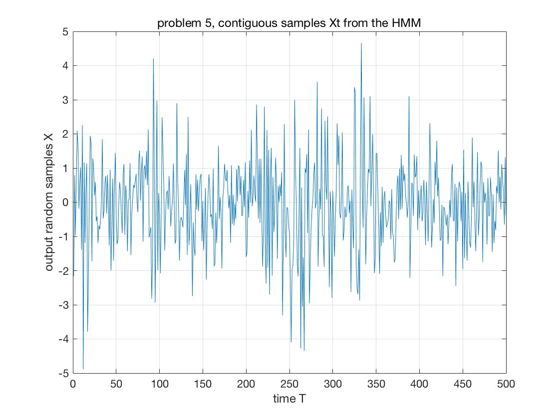

similarity:

the variance keeps the same, so the shape that output points spreads out is quite same with the problem 4.

difference:

since the mean of two Gaussian distribution is the same, so for one output point is difficult to distinguish which state it belongs to.

**Problem 6:**

Change the original, square transition probability matrix into the following:

mc = MarkovChain([0.75;0.25], [0.97 0.02 0.01;0.03 0.95 0.02]);

run the code we get the output

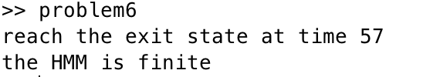

**problem 7:**

figure 1:

distribution 1, mean[0;0], covariance[2 1;1 4]

distribution 2, mean[0;0], covariance[2 0;0 4]

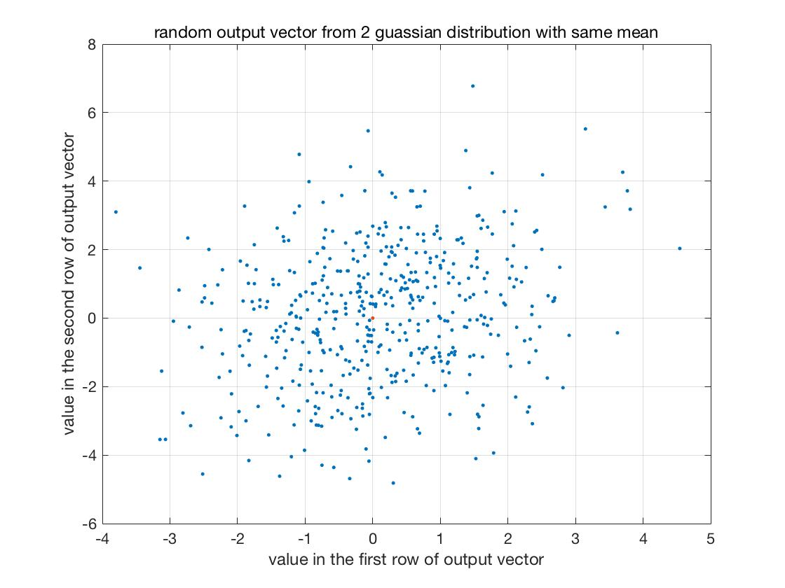

figure 2:

distribution 1, mean[0;0], covariance[2 1;1 4]

distribution 2, mean[5;5], covariance[2 1;1 4]

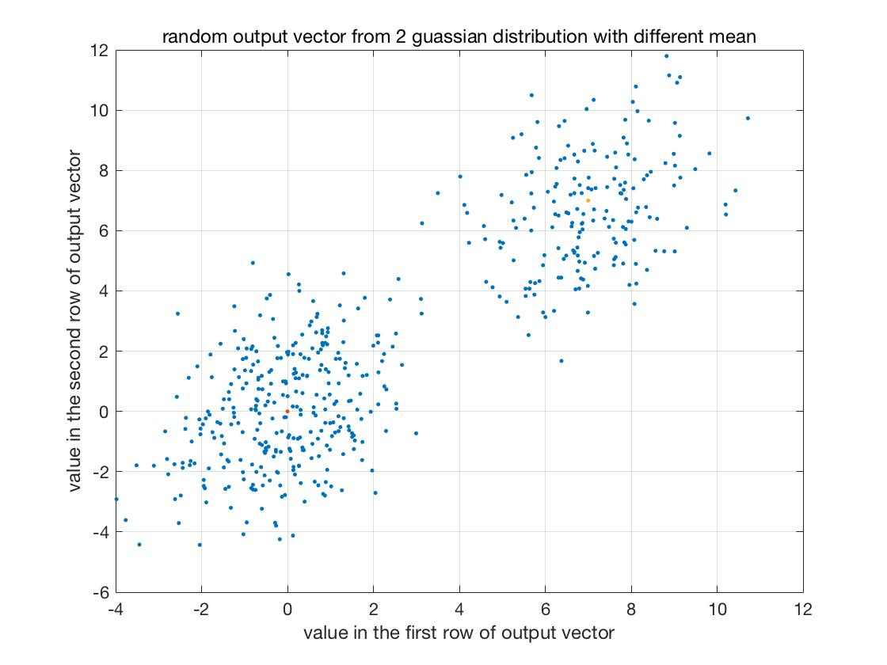

the result above indicates all codes are right. and from the second figure, it shows that all data points are clearly divide into 2 clusters because of different means.

Red points show where the mean vector locates.

QUESTION 6

In the code below, simply use the function if to decide whether the loop reaches the exit state. If yes, jump out of the loop. Otherwise, the loop continues.

if index == nS + 1

        disp(['reach the exit state at time ', num2str(t)])

        break

    end

In order to test this code also works for finite-durations HMM, the probability transition matrix needs to be modified while the initial state keeps the same.

$q=\left(\begin{matrix}0.75 \\ 0.25\end{matrix}\right) A=(\begin{matrix}0.97 & 0.02 & 0.01 \\ 0.03 & 0.95 & 0.02\end{matrix})$

The following is the outcome from MATLAB, easily find the loop terminated at time 43 because it reaches the exit state, the corresponding length of output sequences should be T-1=42.

>> problem6

reach the exit state at time 43

the HMM is finite, the length of output sequences is 42

Question 7

In order to test the code is also suitable for vector-value, the output distribution needs to be modified. Here we use 2-dimension GAUSSIAN distribution instead of 1-dimension. The following is how 2-dimension GAUSSIAN distributions are formulated in the code. Here the given GaussD function is used to build a object/distribution.

u1 = [0;0];

cov1 = [2 1;1 4];

u2 = [0;0];

cov2 = [2 0;0 4];

u3 = [7;7];

cov3 = [2 1;1 4];

g1 = GaussD('Mean',u1,'Covariance',cov1);

g2 = GaussD('Mean',u2,'Covariance',cov2);

g3 = GaussD('Mean',u3,'Covariance',cov3);